Are you ready?

to
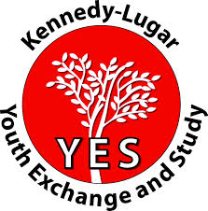
- spend one year in the USA?
- learn about American culture?
- share your culture?
- grow as a person?

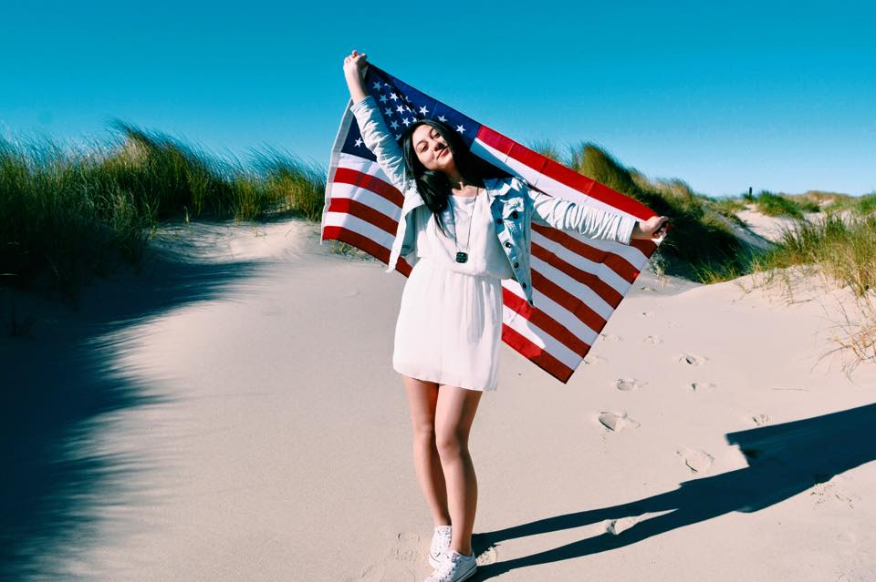
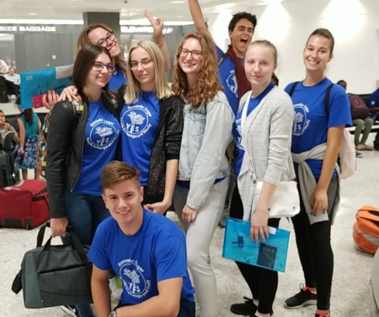
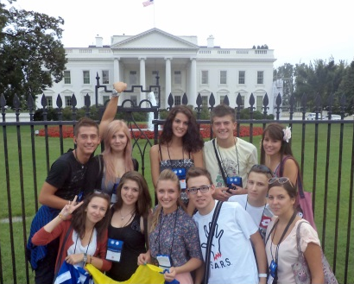
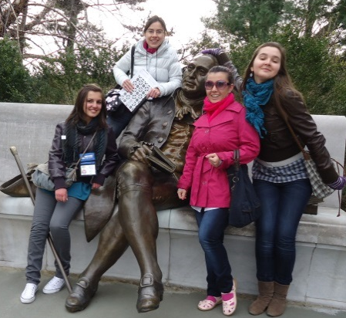

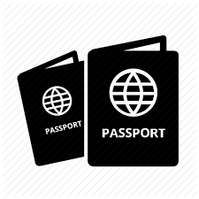
YES offers high school students in Bosnia and Herzegovina the chance to live with an American family and study at an American high school for a year—for FREE! YES is fully funded by the U.S. State Department and implemented by American Councils. If you are:


- in the 1st or 2nd year of high school
- have “very good” or better marks and
- were born 1 January 2002 - 15 July 2004
(Students with disabilities of any grade can apply if they were born between 15 February 2001 and 15 July 2004.)
Bring a pen, a recent 3x4 cm photo, and your passport, birth certificate or ID card to the testing center nearest you. In BiH we test at:
CITY | DATE | LOCATION
BANJA LUKA | 15 September 2018 | Gimnazija Banja Luka, Zmaj Jovina 13
TUZLA | 17 September 2018 | JU Nacionalna i Univerzitetska biblioteka “Derviš Sušić”
MOSTAR | 20 September 2018 | Centar za kulturu Mostar, Rade Bitange 13
SARAJEVO | 22 September 2018 | Druga gimnazija Sarajevo

Testing in all locations begins at: 8:30 am. Please do NOT contact testing locations directly.

More info at: www.ac-see.org; email: sarajevo@americancouncilssee.org or call +387 33 838 262.

